LAB 2

Ayushi Gupta

CSE -SEC A

ROLL NO.-47

1. Difference between two sets:

/\*\*\*\*\*\*\*\*\*\*\*\*\*\*\*\*\*\*\*\*\*\*\*\*\*\*

Online C Compiler.

Code, Compile, Run and Debug C program online.

Write your code in this editor and press "Run" button to compile and execute it.

\*\*\*\*\*\*\*\*\*\*\*\*\*\*\*\*\*\*\*\*\*\*\*\*\*\*\*/

#include <stdio.h>

int main()

{ int m ,n,k,f,j,i;

scanf("%d %d",&m ,&n);

int a[50],b[50],c[50];

for (i=0 ; i<m ; i++)

{

scanf("%d",&a[i]);

}

for (i=0 ; i<n ; i++)

{

scanf("%d",&b[i]);

}

printf("First set is.......................................................\n");

for (i=0 ; i<m ; i++)

{

printf("%d ",a[i]);

}

printf("\nSecond set is.......................................................\n");

for (i=0 ; i<n;i++)

{

printf("%d ",b[i]);

}

k=0;

for(i=0 ; i<m ; i++)

{f=0;

for(j=0 ; j<n ; j++)

{

if(a[i]==b[j])

{

f=0;

break;

}

else

f=1;

}

if(f==1)

{

c[k]=a[i];

k++;

}

}

printf(" \nDifference is,,,,,,,,,,,,,,,,,,,,,,,,,,,,,,,,,,,,,,,,,,,,,,,,,,\n");

for(i=0 ; i<k ;i++)

{

printf("%d ",c[i]);

}

return 0;

}

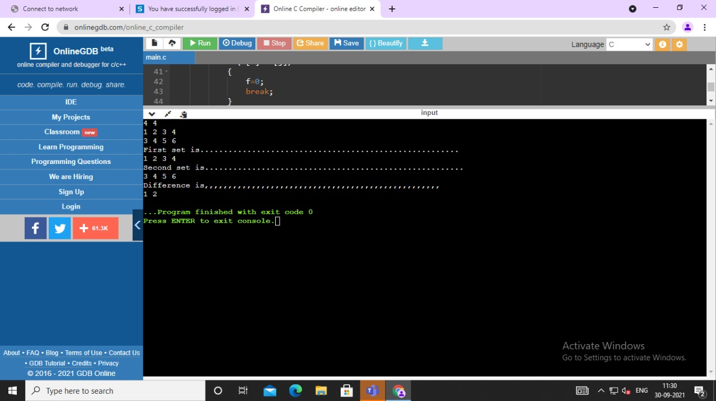

2-Symmetric Difference of two sets:  
/\*\*\*\*\*\*\*\*\*\*\*\*\*\*\*\*\*\*\*\*\*\*\*\*\*\*

Online C Compiler.

Code, Compile, Run and Debug C program online.

Write your code in this editor and press "Run" button to compile and execute it.

\*\*\*\*\*\*\*\*\*\*\*\*\*\*\*\*\*\*\*\*\*\*\*\*\*\*\*/

#include <stdio.h>

int main()

{ int m ,n,k,f,j,i;

scanf("%d %d",&m ,&n);

int a[50],b[50],c[50];

for (i=0 ; i<m ; i++)

{

scanf("%d",&a[i]);

}

for (i=0 ; i<n ; i++)

{

scanf("%d",&b[i]);

}

printf("First set is.......................................................\n");

for (i=0 ; i<m ; i++)

{

printf("%d ",a[i]);

}

printf("\nSecond set is.......................................................\n");

for (i=0 ; i<n;i++)

{

printf("%d ",b[i]);

}

k=0;

for(i=0 ; i<m ; i++)

{f=0;

for(j=0 ; j<n ; j++)

{

if(a[i]==b[j])

{

f=0;

break;

}

else

f=1;

}

if(f==1)

{

c[k]=a[i];

k++;

}

}

for(i=0 ; i<n ; i++)

{f=0;

for(j=0 ; j<m ; j++)

{

if(b[i]==a[j])

{

f=0;

break;

}

else

f=1;

}

if(f==1)

{

c[k]=b[i];

k++;

}

}

printf(" \n Symmetric Difference is,,,,,,,,,,,,,,,,,,,,,,,,,,,,,,,,,,,,,,,,,,,,,,,,,,\n");

for(i=0 ; i<k ;i++)

{

printf("%d ",c[i]);

}

return 0;

}

